Functional Models
Barcode Governance & Risk Intelligence System (BGRIS)
Shailaja Sirikonda, Systems Analyst
February 10, 2026

- Use Case Diagram
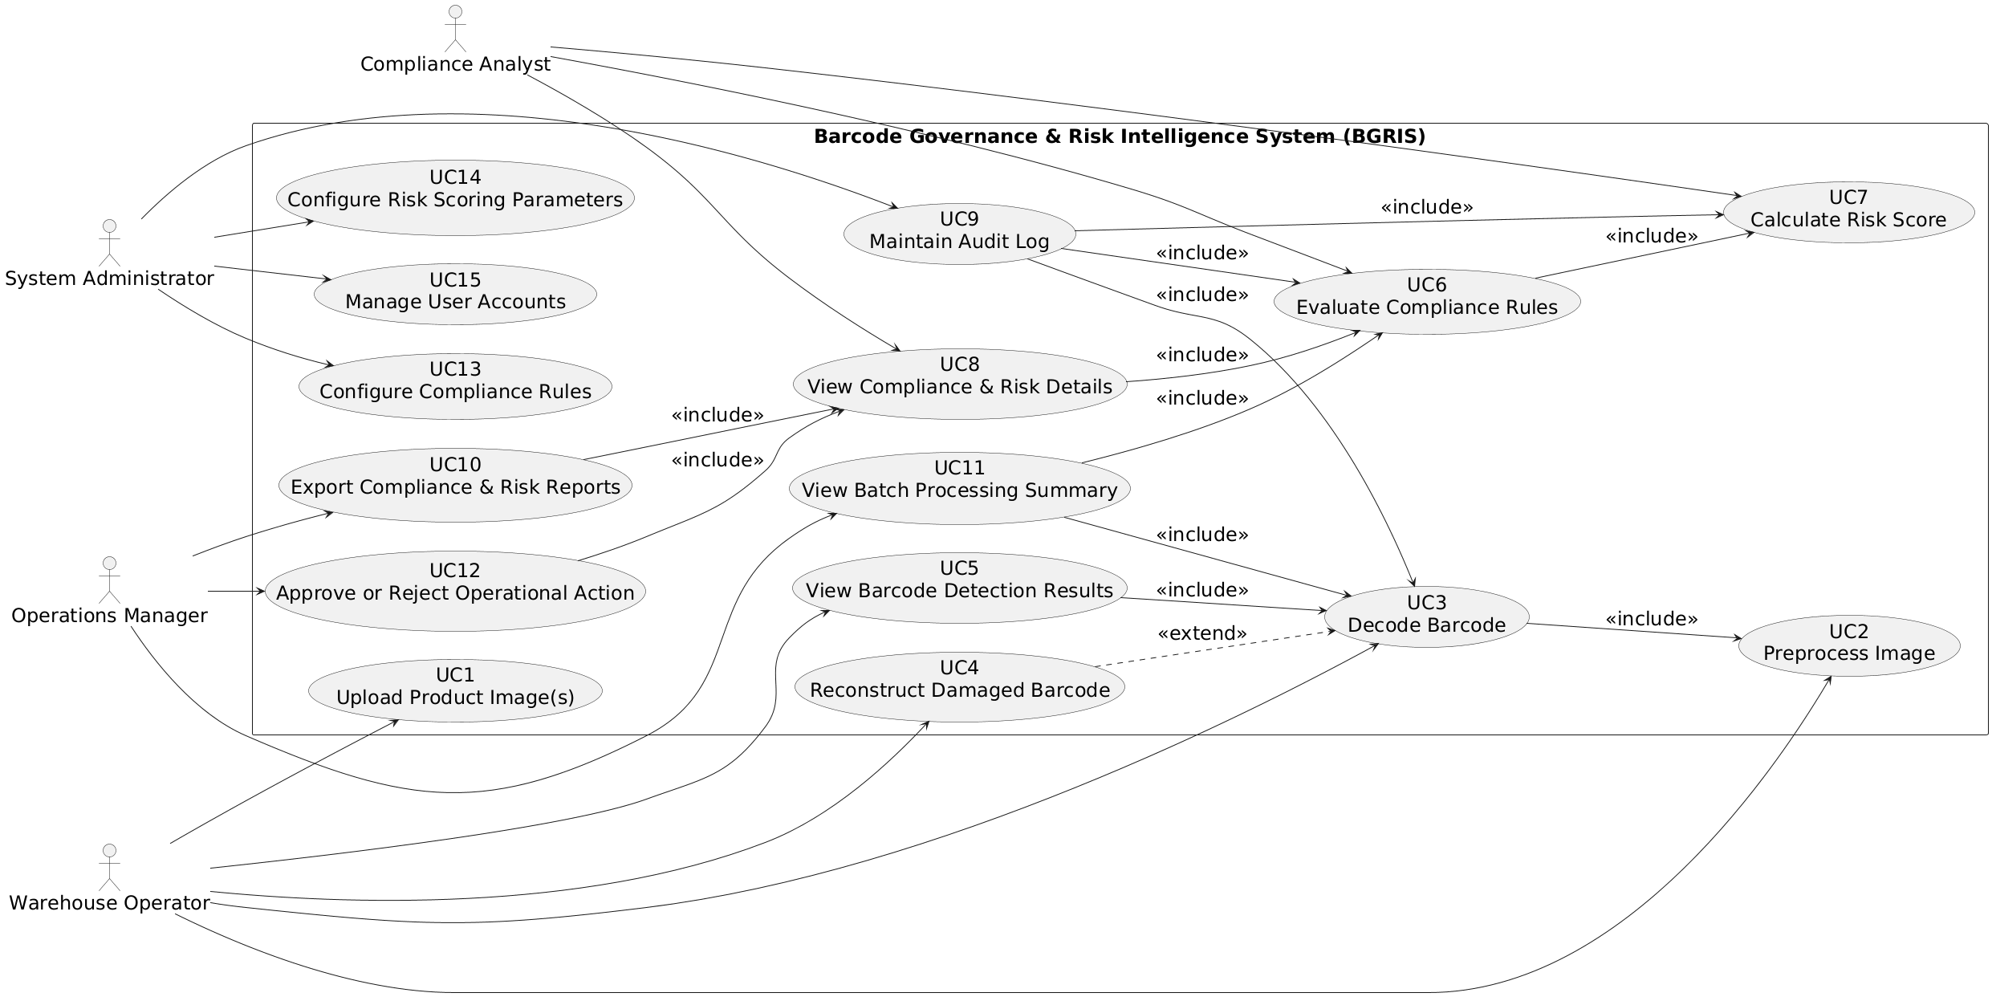
Diagram 1: Use Case Diagram for “Barcode Governance & Risk Intelligence System”
- Use Case Description
Use Case - 1
Use Case Name: Upload Product Image(s) |  | ID:UC1 | Importance Level: High
Primary Actor: Warehouse Operator | Use Case Type: Primary
Stakeholders and Interests: The Warehouse Operator has an interest in quickly and accurately submitting product images for barcode analysis during daily operations. The Operations Manager has an interest in ensuring that uploaded images are correctly captured to support reliable batch processing and downstream reporting. The organization has an interest in maintaining accurate and auditable input data as the foundation for barcode decoding, compliance evaluation, and risk assessment within the Barcode Governance & Risk Intelligence System (BGRIS).
Brief Description: This use case allows a Warehouse Operator to upload a single product image or a batch of product images containing one or more barcodes into the system for further processing.
Trigger: The Warehouse Operator selects the option to upload product image(s) into the system.
Type: External
Relationships:
Association: Warehouse Operator
Include: None
Extend: None
Generalization: None
Normal Flow of Events:
- The Warehouse Operator selects the upload image option from the system interface.
- The system prompts the Warehouse Operator to choose one or more image files from local storage.
- The Warehouse Operator selects the desired image file(s) and confirms the upload.
- The system validates the selected files for supported image formats.
- The system stores the uploaded image file(s) locally and confirms successful upload to the Warehouse Operator.
SubFlows:
S-1: The system validates each uploaded image file to ensure it is readable and in a supported format.
Alternate/Exceptional Flows:
A-1: If an uploaded file is not a supported image format, the system rejects the file and displays an error message to the Warehouse Operator.
A-2: If an image file is corrupted or unreadable, the system logs the error and allows the Warehouse Operator to continue uploading remaining valid files.

This use case description is covering the requirements – FR-1, FR-2

Use Case - 2
Use Case Name: Preprocess Image |  | ID:UC-2 | Importance Level: High
Primary Actor: Warehouse Operator | Use Case Type: Primary
Stakeholders and Interests: The Warehouse Operator has an interest in improving image quality to increase barcode readability before decoding. The Compliance Analyst has an interest in ensuring that higher-quality images lead to more accurate barcode extraction and downstream compliance evaluation. The organization has an interest in reducing barcode decoding failures caused by poor image quality, thereby improving operational efficiency and decision accuracy within the Barcode Governance & Risk Intelligence System (BGRIS).
Brief Description: This use case allows a Warehouse Operator to apply image preprocessing techniques such as rotation correction, noise reduction, and contrast enhancement to uploaded product images prior to barcode decoding.
Trigger: The Warehouse Operator selects the option to preprocess an uploaded image.
Type: External
Relationships:
Association: Warehouse Operator
Include: None
Extend: None
Generalization: None
Normal Flow of Events:
- The Warehouse Operator selects a previously uploaded image for preprocessing.
- The system displays available preprocessing options to the Warehouse Operator.
- The Warehouse Operator selects one or more preprocessing options and confirms the request.
- The system applies the selected preprocessing techniques to the image.
- The system stores the preprocessed image and displays a confirmation to the Warehouse Operator.
SubFlows:
S-1: The system applies preprocessing algorithms to correct image orientation, reduce noise, and enhance contrast.
Alternate/Exceptional Flows:
A-1: If preprocessing fails due to image corruption, the system displays an error message and retains the original image.
A-2: If the Warehouse Operator cancels preprocessing, the system exits the use case without modifying the image.

This use case description is covering the requirements – FR-4, FR-9

Use Case - 3
Use Case Name: Decode Barcode |  | ID:UC-3 | Importance Level: High
Primary Actor: Warehouse Operator | Use Case Type: Primary
Stakeholders and Interests: The Warehouse Operator has an interest in accurately extracting barcode data from uploaded product images to support daily operational processing. The Compliance Analyst has an interest in receiving correct barcode values to enable reliable compliance evaluation and risk scoring. The Operations Manager has an interest in ensuring that barcode decoding is performed consistently across batch runs to support trustworthy reporting and decision-making within the Barcode Governance & Risk Intelligence System (BGRIS).
Brief Description: This use case allows a Warehouse Operator to initiate barcode decoding on an uploaded and optionally preprocessed product image in order to extract barcode values for further analysis.
Trigger: The Warehouse Operator selects the option to decode barcodes for an uploaded image.
Type: External
Relationships:
Association: Warehouse Operator
Include: Use Case 2 – Preprocess Image
Extend: None
Generalization: None
Normal Flow of Events:
- The Warehouse Operator selects an uploaded image for barcode decoding.
- The system includes Use Case 2 – Preprocess Image to ensure the image is prepared for decoding.
- The system analyzes the image and detects one or more barcode regions.
- The system decodes readable barcodes and extracts barcode values.
- The system stores the decoded barcode data and confirms completion to the Warehouse Operator.
SubFlows:
S-1: The system identifies barcode regions and attempts decoding for each detected region.
Alternate/Exceptional Flows:
A-1: If no readable barcode is detected, the system notifies the Warehouse Operator that decoding was unsuccessful.
A-2: If barcode data is partially unreadable, the system marks the barcode as eligible for Use Case 4 – Reconstruct Damaged Barcode.

This use case description is covering the requirements – FR-3, FR-5, FR-6

Use Case - 4
Use Case Name: Reconstruct Damaged Barcode |  | ID:UC-4 | Importance Level: Medium
Primary Actor: Warehouse Operator | Use Case Type: Primary
Stakeholders and Interests: The Warehouse Operator has an interest in recovering usable barcode data from partially unreadable images to avoid manual rework or inventory delays. The Compliance Analyst has an interest in understanding the confidence level associated with reconstructed barcode data to support accurate compliance and risk evaluation. The organization has an interest in minimizing data loss caused by damaged barcodes while maintaining explainable and auditable reconstruction decisions within the Barcode Governance & Risk Intelligence System (BGRIS).
Brief Description: This use case allows a Warehouse Operator to initiate reconstruction of a partially unreadable barcode when standard decoding is insufficient.
Trigger: The Warehouse Operator selects the option to reconstruct a damaged barcode after a failed or partial decode.
Type: External
Relationships:
Association: Warehouse Operator
Include: None.
Extend: Use Case 3 – Decode Barcode
Generalization: None
Normal Flow of Events:
- The Warehouse Operator selects a partially decoded barcode for reconstruction.
- The system applies reconstruction algorithms to infer missing or damaged barcode segments.
- The system calculates a reconstruction confidence score.
- The system stores the reconstructed barcode value with its confidence indicator.
- The system notifies the Warehouse Operator that reconstruction is complete.
SubFlows:
S-1: The system evaluates pattern consistency and checksum validity during reconstruction.
Alternate/Exceptional Flows:
A-1: If reconstruction confidence is below the acceptable threshold, the system marks the barcode as unreadable.
A-2: If reconstruction fails entirely, the system logs the failure and informs the Warehouse Operator.

This use case description is covering the requirements – FR-6, FR-7, FR-8

Use Case - 5
Use Case Name: View Barcode Detection Results |  | ID:UC-5 | Importance Level: High
Primary Actor: Warehouse Operator | Use Case Type: Primary
Stakeholders and Interests: The Warehouse Operator wants to view both detected and reconstructed barcode values to verify processing results. The Compliance Analyst has an interest in seeing accurate decoded and reconstructed data for downstream compliance evaluation. The Operations Manager relies on this information to monitor batch processing accuracy. The organization values traceable and auditable barcode results within the Barcode Governance & Risk Intelligence System (BGRIS).
Brief Description: This use case allows a Warehouse Operator to view the results of barcode detection and any reconstructed barcode values for a selected image.
Trigger: The Warehouse Operator selects the option to view detection results for a processed image.
Type: External
Relationships:
Association: Warehouse Operator
Include: Use Case 3 – Decode Barcode
Extend: None
Generalization: None
Normal Flow of Events:
- The Warehouse Operator selects a processed image to view results.
- The system includes Use Case 3 – Decode Barcode to ensure barcode data is available.
- The system displays detected barcode regions overlaid on the original image.
- The system shows reconstructed barcode values alongside the detected values.
- The system allows the Warehouse Operator to confirm or flag unreadable barcodes.
SubFlows:
S-1: The system highlights each barcode region and differentiates reconstructed values from original detections.
Alternate/Exceptional Flows:
A-1: If no barcode data exists for the selected image, the system notifies the Warehouse Operator.
A-2: If an image was not preprocessed and decoding fails, the system suggests reprocessing via Use Case 2 – Preprocess Image.

This use case description is covering the requirements – FR-5, FR-7

Use Case - 6
Use Case Name: Evaluate Compliance Rules |  | ID:UC-6 | Importance Level: High
Primary Actor: Compliance Analyst | Use Case Type: Primary
Stakeholders and Interests: The Compliance Analyst wants to ensure that barcodes comply with governance rules before operational decisions are made. The Warehouse Operator benefits indirectly because compliance issues are flagged early, reducing manual corrections. The Operations Manager relies on accurate compliance evaluation for risk management and batch approval. The organization values reliable, auditable, and explainable compliance assessments within the Barcode Governance & Risk Intelligence System (BGRIS).
Brief Description: This use case allows a Compliance Analyst to apply governance rules to decoded and reconstructed barcode data to evaluate compliance.
Trigger: The Compliance Analyst selects the option to evaluate compliance rules on a set of processed barcode data.
Type: External
Relationships:
Association: Compliance Analyst
Include: Use Case 7 – Calculate Risk Score
Extend: None
Generalization: None
Normal Flow of Events:
- The Compliance Analyst selects processed barcode data for evaluation.
- The system applies predefined governance rules to each barcode.
- The system calculates risk scores using Use Case 7 – Calculate Risk Score.
- The system records rule violations and evaluation results.
- The system displays compliance outcomes and any violations to the Compliance Analyst.
SubFlows:
S-1: The system tracks applied rules and their dependencies to ensure accurate evaluation order.
Alternate/Exceptional Flows:
A-1: If a barcode has incomplete or missing data, the system flags it and suggests reconstruction via Use Case 4 – Reconstruct Damaged Barcode.
A-2: If a rule evaluation fails due to invalid configuration, the system logs the error and continues evaluating other barcodes.

This use case description is covering the requirements – FR-11, FR-12, FR-13

Use Case - 7
Use Case Name: Calculate Risk Score |  | ID:UC-7 | Importance Level: High
Primary Actor: Compliance Analyst | Use Case Type: Primary
Stakeholders and Interests: The Compliance Analyst wants risk scores for barcodes to prioritize attention to high-risk items. The Operations Manager relies on risk scores to make informed decisions about batch approvals and operational actions. The Warehouse Operator benefits indirectly because high-risk barcodes are identified for reprocessing or reconstruction. The organization values quantified, explainable, and auditable risk scoring within the Barcode Governance & Risk Intelligence System (BGRIS).
Brief Description: This use case allows a Compliance Analyst to compute a risk score for each barcode based on rule violations and reconstruction confidence.
Trigger: The Compliance Analyst selects the option to calculate risk scores for processed barcode data.
Type: External
Relationships:
Association: Compliance Analyst
Include: None
Extend: None
Generalization: None
Normal Flow of Events:
- The Compliance Analyst selects processed barcode data for risk evaluation.
- The system retrieves applicable rule violations and reconstruction confidence scores.
- The system calculates a risk score for each barcode using predefined weighting parameters.
- The system stores calculated risk scores alongside barcode data.
- The system displays risk scores and related explanations to the Compliance Analyst.
SubFlows:
S-1: The system combines rule violation severity and reconstruction confidence to generate a single risk score per barcode.
Alternate/Exceptional Flows:
A-1: If required data for risk calculation is missing, the system flags the barcode and skips risk scoring.
A-2: If calculation fails due to configuration errors, the system logs the issue and continues processing other barcodes.

This use case description is covering the requirements – FR-15, FR-16

Use Case - 8
Use Case Name: View Compliance & Risk Details |  | ID:UC-8 | Importance Level: High
Primary Actor: Compliance Analyst | Use Case Type: Primary
Stakeholders and Interests: The Compliance Analyst wants to review detailed compliance results, including rule violations, risk scores, and reconstruction confidence, to make informed assessments. The Operations Manager relies on accurate and traceable compliance data to approve or reject operational actions. The Warehouse Operator indirectly benefits by receiving clear feedback on barcodes that need reprocessing. The organization values explainable, auditable, and actionable compliance and risk information within the Barcode Governance & Risk Intelligence System (BGRIS).
Brief Description: This use case allows a Compliance Analyst to view detailed compliance outcomes and risk scores for processed barcodes.
Trigger: The Compliance Analyst selects the option to view compliance and risk details for one or more barcodes.
Type: External
Relationships:
Association: Compliance Analyst
Include: Use Case 6 – Evaluate Compliance Rules
Extend: None
Generalization: None
Normal Flow of Events:
- The Compliance Analyst selects processed barcode data to review.
- The system includes Use Case 6 – Evaluate Compliance Rules to ensure compliance evaluation is complete.
- The system displays rule violations, reconstruction confidence, and calculated risk scores for each barcode.
- The system highlights barcodes with high-risk scores for further review or action.
- The Compliance Analyst can filter or sort results to focus on specific compliance issues.
SubFlows:
S-1: The system shows detailed decision paths explaining which rules and confidence values contributed to the risk score.
Alternate/Exceptional Flows:
A-1: If compliance evaluation is incomplete, the system prompts the Compliance Analyst to run Use Case 6 – Evaluate Compliance Rules first.
A-2: If barcode data is missing or corrupted, the system flags the item and excludes it from the displayed results.

This use case description is covering the requirements – FR-11, FR-12, FR-13, FR-15, FR-16, FR-17, FR-18, FR-19, FR-20
Use Case - 9
Use Case Name: Maintain Audit Log |  | ID:UC-9 | Importance Level: High
Primary Actor: System | Use Case Type: Supporting
Stakeholders and Interests: The System Administrator wants all system actions, including barcode decoding, compliance evaluation, and risk scoring, to be recorded automatically for traceability and audit purposes. The Compliance Analyst and Operations Manager rely on accurate audit logs to verify processing integrity. The organization values accountability, tamper-resistant records, and explainable decisions within the Barcode Governance & Risk Intelligence System (BGRIS).
Brief Description: This use case ensures that the system automatically logs all relevant actions, including barcode decoding, compliance evaluation, and risk scoring, to maintain a complete audit trail.
Trigger: Any system action related to barcode processing, compliance evaluation, or risk scoring occurs.
Type: Automatic
Relationships:
Association: System Administrator
Include: Use Case 3 – Decode Barcode, Use Case 6 – Evaluate Compliance Rules, Use Case 7 – Calculate Risk Score
Extend: None
Generalization: None
Normal Flow of Events:
- The system detects an action to be logged.
- The system captures relevant details, including timestamps, actor identifiers, and action type.
- The system stores the log in a tamper-resistant format.
- The system links the log entries to the corresponding barcode data.
- The system confirms that the audit entry is complete and accessible for future review.
SubFlows:
S-1: The system periodically verifies the integrity of stored logs to ensure no data corruption.
Alternate/Exceptional Flows:
A-1: If logging fails due to storage issues, the system retries and notifies the System Administrator.
A-2: If audit entries cannot be linked to specific actions, the system flags the event for manual review.

This use case description is covering the requirements – FR-27, FR-29, FR-30, FR-38, FR-40

Use Case - 10
Use Case Name: Export Compliance & Risk Reports |  | ID:UC-10 | Importance Level: Medium
Primary Actor: Operations Manager | Use Case Type: Primary
Stakeholders and Interests: The Operations Manager wants to generate and export batch-level compliance and risk reports in JSON or CSV formats to support audits and operational decisions. The Compliance Analyst benefits from clear, shareable data for review, and the Warehouse Operator benefits indirectly by ensuring that processed barcodes are accounted for. The organization values accurate, auditable, and shareable reporting within the Barcode Governance & Risk Intelligence System (BGRIS).
Brief Description: This use case allows an Operations Manager to export compliance and risk results for processed barcode data in standard formats.
Trigger: The Operations Manager selects the option to export reports for a batch of processed barcodes.
Type: External
Relationships:
Association: Operations Manager
Include: Use Case 8 – View Compliance & Risk Details
Extend: None
Generalization: None
Normal Flow of Events:
- The Operations Manager selects the batch of processed barcode data to export.
- The system includes Use Case 8 – View Compliance & Risk Details to ensure the data is current.
- The system formats the compliance and risk data into JSON or CSV.
- The system provides the file for download.
- The Operations Manager confirms successful export.
SubFlows:
S-1: The system validates data integrity before export to ensure accurate reporting.
Alternate/Exceptional Flows:
A-1: If the batch contains incomplete or missing data, the system warns the Operations Manager and excludes affected barcodes from the report.
A-2: If file export fails due to storage or permission issues, the system logs the error and notifies the Operations Manager.

This use case description is covering the requirements – FR-19, FR-28, FR-40

Use Case - 11
Use Case Name: View Batch Processing Summary |  | ID:UC-11 | Importance Level: Medium
Primary Actor: Operations Manager | Use Case Type: Primary
Stakeholders and Interests: The Operations Manager wants to review batch-level statistics, including compliance results, risk scores, and processing outcomes, to monitor operational efficiency. The Compliance Analyst benefits from summarized insights for review, while Warehouse Operators gain indirect benefits through improved process oversight. The organization values accurate, actionable, and auditable batch-level reporting within the Barcode Governance & Risk Intelligence System (BGRIS).
Brief Description: This use case allows an Operations Manager to view summary statistics and outcomes for a batch of processed barcode images.
Trigger: The Operations Manager selects the option to view a batch summary after processing is complete.
Type: External
Relationships:
Association: Operations Manager
Include: Use Case 3 – Decode Barcode, Use Case 6 – Evaluate Compliance Rules
Extend: None
Generalization: None
Normal Flow of Events:
- The Operations Manager selects a completed batch to review.
- The system includes Use Case 3 – Decode Barcode and Use Case 6 – Evaluate Compliance Rules to ensure all processing is complete.
- The system generates a summary including total barcodes processed, compliance status, risk scores, and detected issues.
- The system displays the batch summary in a dashboard or table format.
- The Operations Manager reviews the summary to identify high-risk items or trends.
SubFlows:
S-1: The system allows filtering and sorting of summary data by compliance status, risk level, or barcode type.
Alternate/Exceptional Flows:
A-1: If batch data is incomplete or missing, the system warns the Operations Manager and only shows available data.
A-2: If processing logs are unavailable, the system flags the batch for re-evaluation.

This use case description is covering the requirements – FR-21, FR-22, FR-23, FR-26, FR-29

Use Case – 12
Use Case Name: Approve or Reject Operational Action |  | ID:UC-12 | Importance Level: High
Primary Actor: Operations Manager | Use Case Type: Primary
Stakeholders and Interests: The Operations Manager wants to make final decisions on inventory actions based on compliance and risk outcomes. The Compliance Analyst relies on accurate evaluations to inform these decisions. The Warehouse Operator benefits by knowing which items require action or reprocessing. The organization values controlled, auditable, and accountable decision-making within the Barcode Governance & Risk Intelligence System (BGRIS).
Brief Description: This use case allows an Operations Manager to approve or reject operational actions for items in a processed batch based on compliance and risk evaluations.
Trigger: The Operations Manager selects the option to review and decide on operational actions for barcodes in a batch.
Type: External
Relationships:
Association: Operations Manager
Include: Use Case 8 – View Compliance & Risk Details
Extend: None
Generalization: None
Normal Flow of Events:
- The Operations Manager reviews batch-level compliance and risk details by including Use Case 8 – View Compliance & Risk Details.
- The Operations Manager identifies items requiring approval or rejection.
- The Operations Manager marks each item as approved or rejected.
- The system records the decisions in the audit log (Use Case 9 – Maintain Audit Log).
- The system confirms that operational actions have been applied to the selected items.
SubFlows:
S-1: The system highlights high-risk items for prioritized review before approval or rejection.
Alternate/Exceptional Flows:
A-1: If decision data is missing or incomplete, the system prompts the Operations Manager to review affected items.
A-2: If the system cannot record decisions due to audit log issues, it warns the Operations Manager and prevents finalizing actions.

This use case description is covering the requirements – FR-24, FR-25

Use Case - 13
Use Case Name: Configure Compliance Rules |  | ID:UC-13 | Importance Level: High
Primary Actor: System Administrator | Use Case Type: Primary
Stakeholders and Interests: The System Administrator wants to define, modify, and manage barcode compliance rules without changing application code. Compliance Analysts rely on these rules to ensure accurate evaluations, and Operations Managers depend on consistent enforcement for operational decisions. The organization values flexibility, auditability, and maintainability of governance logic within the Barcode Governance & Risk Intelligence System (BGRIS).
Brief Description: This use case allows a System Administrator to create, update, activate, or deactivate barcode compliance rules using JSON or CSV configuration files.
Trigger: The System Administrator selects the option to configure compliance rules.
Type: External
Relationships:
Association: System Administrator
Include: None
Extend: None
Generalization: None
Normal Flow of Events:
- The System Administrator opens the compliance rules configuration interface.
- The System Administrator creates new rules or modifies existing ones using JSON or CSV files.
- The System Administrator activates or deactivates specific rules.
- The system validates the rules for syntax and logical consistency.
- The system saves the updated rules and confirms successful configuration.
SubFlows:
S-1: The system maintains version history of rule changes for audit purposes.
Alternate/Exceptional Flows:
A-1: If rule files contain errors, the system rejects them and prompts the System Administrator to correct issues.
A-2: If saving fails due to permission or storage issues, the system alerts the System Administrator and aborts the operation.

This use case description is covering the requirements – FR-31, FR-32, FR-33, FR-34

Use Case - 14
Use Case Name: Configure Risk Scoring Parameters |  | ID:UC-14 | Importance Level: Medium
Primary Actor: System Administrator | Use Case Type: Primary
Stakeholders and Interests: The System Administrator wants to adjust the weighting and thresholds used to calculate barcode risk scores to ensure accurate and meaningful evaluations. Compliance Analysts rely on precise scoring to identify high-risk items, and Operations Managers depend on correct scores to make operational decisions. The organization values configurable, transparent, and auditable risk calculations within the Barcode Governance & Risk Intelligence System (BGRIS).
Brief Description: This use case allows a System Administrator to configure risk-scoring parameters, including weights and thresholds, that determine how barcode compliance and reconstruction data contribute to overall risk scores.
Trigger: The System Administrator selects the option to configure risk scoring parameters.
Type: External
Relationships:
Association: System Administrator
Include: None
Extend: None
Generalization: None
Normal Flow of Events:
- The System Administrator opens the risk scoring configuration interface.
- The System Administrator adjusts weights and threshold values for the risk calculation.
- The system validates parameter ranges to prevent errors in scoring.
- The system saves the updated parameters and confirms successful configuration.
SubFlows:
S-1: The system maintains a history of risk parameter changes for audit and traceability purposes.
Alternate/Exceptional Flows:
A-1: If parameter values are out of acceptable ranges, the system rejects the changes and prompts the System Administrator to correct them.
A-2: If saving fails due to storage or permission issues, the system alerts the System Administrator and aborts the operation.

This use case description is covering the requirements – FR-35

Use Case - 15
Use Case Name: Manage User Accounts |  | ID:UC-15 | Importance Level: High
Primary Actor: System Administrator | Use Case Type: Primary
Stakeholders and Interests: The System Administrator wants to create, modify, or disable user accounts to control access to the Barcode Governance & Risk Intelligence System (BGRIS). Warehouse Operators, Compliance Analysts, and Operations Managers rely on proper account management to perform their tasks securely. The organization values secure, auditable, and role-based access control to protect system integrity and data confidentiality.
Brief Description: This use case allows a System Administrator to create new users, modify existing user accounts, assign roles, and disable unauthorized or inactive accounts.
Trigger: The System Administrator selects the option to manage user accounts.
Type: External
Relationships:
Association: System Administrator
Include: None
Extend: None
Generalization: None
Normal Flow of Events:
- The System Administrator opens the user account management interface.
- The System Administrator creates new user accounts with assigned roles.
- The System Administrator modifies roles or account details for existing users.
- The System Administrator disables user accounts that are no longer authorized.
- The system confirms the successful creation, modification, or disabling of accounts.
SubFlows:
S-1: The system logs all user account changes for audit purposes.
Alternate/Exceptional Flows:
A-1: If input data is invalid or missing, the system rejects the change and prompts the System Administrator to correct it.
A-2: If changes cannot be saved due to system errors or permission issues, the system alerts the System Administrator and aborts the operation.

This use case description is covering the requirements – FR-36, FR-37
2. Activity Diagram
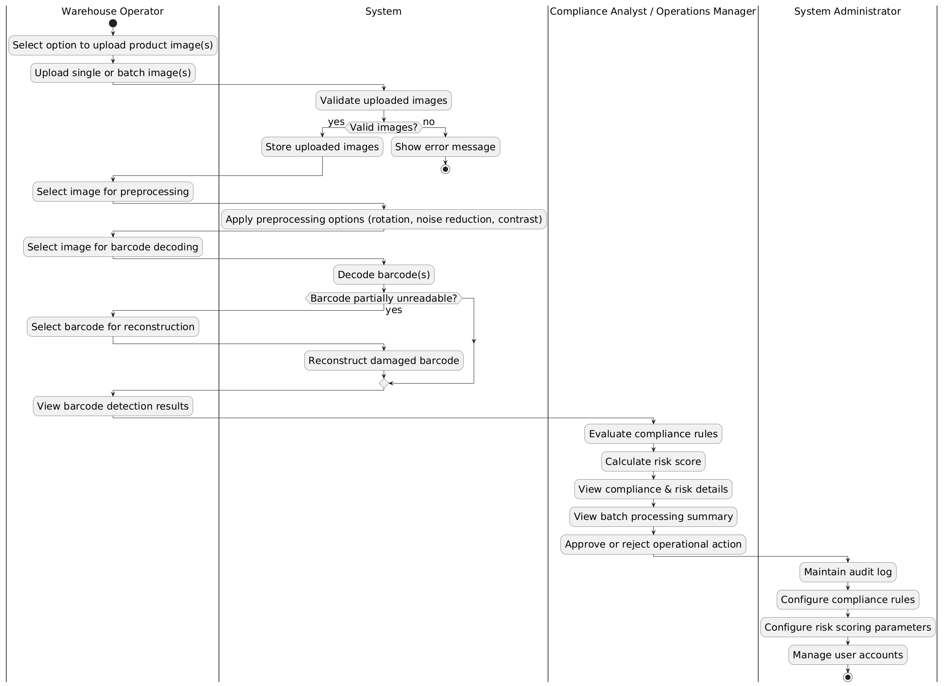
Diagram 2: Activity Diagram for “Barcode Governance & Risk Intelligence System”

